SET 6: PRODUCT SALES ANALYSIS
Aim
Dataset: Monthly Product Sales
Product ID | Product Name | January Sales | February Sales | March Sales
1 | Product A | 2000 | 2200 | 2400
2 | Product B | 1500 | 1800 | 1600
3 | Product C | 1200 | 1400 | 1100

PROGRAM 1: Grouped Bar Chart of Product Sales
Create a grouped bar chart to visualize the sales of each product for the first quarter. Label the chart elements.
# Create product sales data
product <- c("Product A", "Product B", "Product C")

january <- c(2000, 1500, 1200)
february <- c(2200, 1800, 1400)
march <- c(2400, 1600, 1100)

# Combine sales data
sales <- rbind(january, february, march)

# Create grouped bar chart
barplot(sales,
beside = TRUE,
names.arg = product,
main = "Monthly Product Sales - First Quarter",
xlab = "Product",
ylab = "Sales",
col = c("skyblue", "orange", "lightgreen"),
border = "black",
ylim = c(0, 3000))

# Add legend
legend("topleft",
legend = c("January", "February", "March"),
fill = c("skyblue", "orange", "lightgreen"))

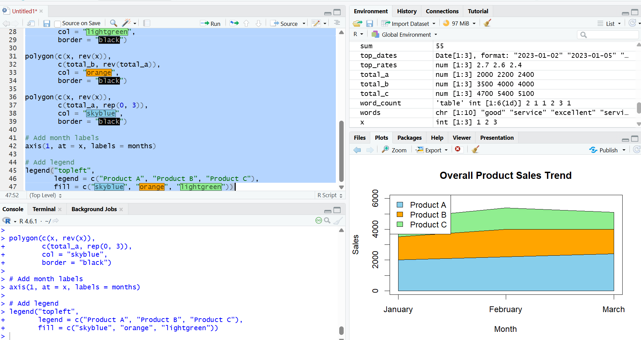

Output 1: First Quarter Product Sales Grouped Bar Chart
Observation
The grouped bar chart compares the January, February, and March sales of each product. Product A has the highest sales in all three months.

PROGRAM 2: Stacked Area Chart of Overall Sales Trend
Generate a stacked area chart to represent the overall sales trend for all products over the three
months.
# Create monthly sales data
months <- c("January", "February", "March")

product_a <- c(2000, 2200, 2400)
product_b <- c(1500, 1800, 1600)
product_c <- c(1200, 1400, 1100)

# Calculate cumulative sales
total_a <- product_a
total_b <- product_a + product_b
total_c <- product_a + product_b + product_c

# Convert months to numeric
x <- 1:3

# Create empty plot
plot(x, total_c,
type = "n",
xaxt = "n",
xlab = "Month",
ylab = "Sales",
main = "Overall Product Sales Trend",
ylim = c(0, 6000))

# Create stacked areas
polygon(c(x, rev(x)),
c(total_c, rep(0, 3)),
col = "lightgreen",
border = "black")

polygon(c(x, rev(x)),
c(total_b, rev(total_a)),
col = "orange",
border = "black")

polygon(c(x, rev(x)),
c(total_a, rep(0, 3)),
col = "skyblue",
border = "black")

# Add month labels
axis(1, at = x, labels = months)

# Add legend
legend("topleft",
legend = c("Product A", "Product B", "Product C"),
fill = c("skyblue", "orange", "lightgreen"))

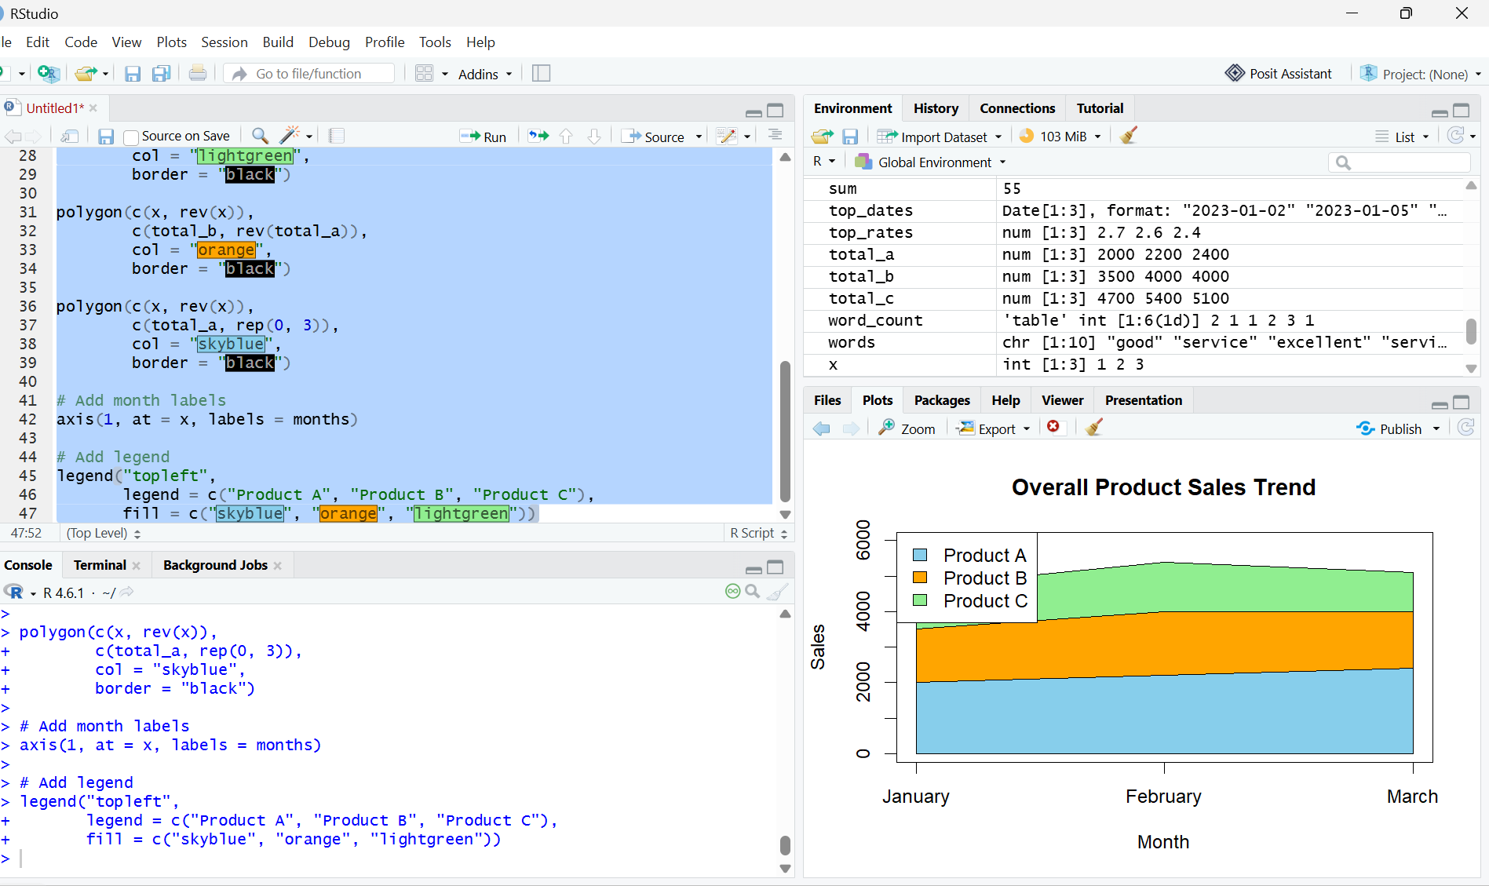
Output 2: Overall Product Sales Stacked Area Chart

Observation: The stacked area chart shows the overall sales trend and contribution of each product during the first quarter.

PROGRAM 3: Monthly Sales Table
Build a table to show the monthly sales data for each product. Label the table elements.
# Create monthly sales data
sales_data <- data.frame(
Product_ID = c(1, 2, 3),
Product_Name = c("Product A", "Product B", "Product C"),
January_Sales = c(2000, 1500, 1200),
February_Sales = c(2200, 1800, 1400),
March_Sales = c(2400, 1600, 1100)
)

# Display the sales table
print(sales_data)

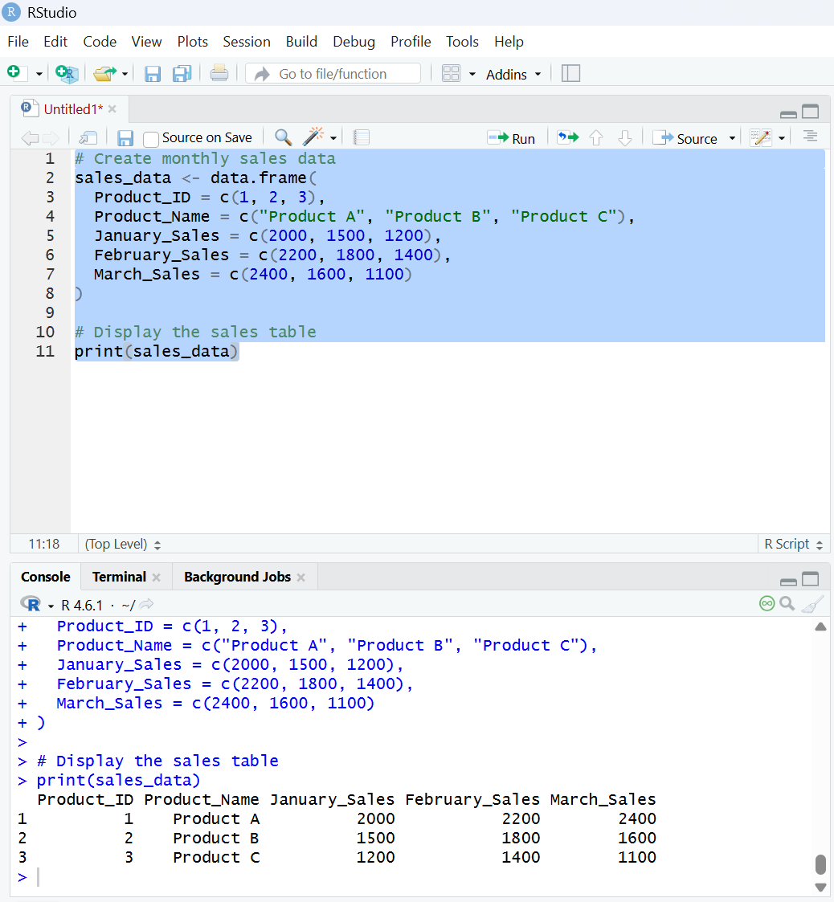
Output 3: Monthly Product Sales Data Table

Observation: The table displays the monthly sales data for each product clearly.

PROGRAM 4: Tableau Dashboard for Product Sales Analysis
Develop a Tableau dashboard combining the grouped bar chart, stacked area chart, and the table
for interactive exploration of sales data.
Procedure:
- Create a monthly product sales dataset containing Product ID, Product Name, January Sales, February Sales, and March Sales.
- Use R to create a grouped bar chart showing the sales of each product for the first quarter.
- Create a stacked area chart to represent the overall sales trend for all products over the three months.
- Create a table to display the monthly sales data for each product.
- Import the Excel monthly product sales dataset into Tableau.
- Create a grouped bar chart in Tableau using Product Name and monthly sales.
- Create a stacked area chart in Tableau to display the sales trend of all products.
- Create a table in Tableau showing the monthly sales data for each product.
- Combine the grouped bar chart, stacked area chart, and table into a Tableau dashboard.
- Add filters or dashboard actions to allow users to interactively explore the product sales data.
- Save the Tableau dashboard.
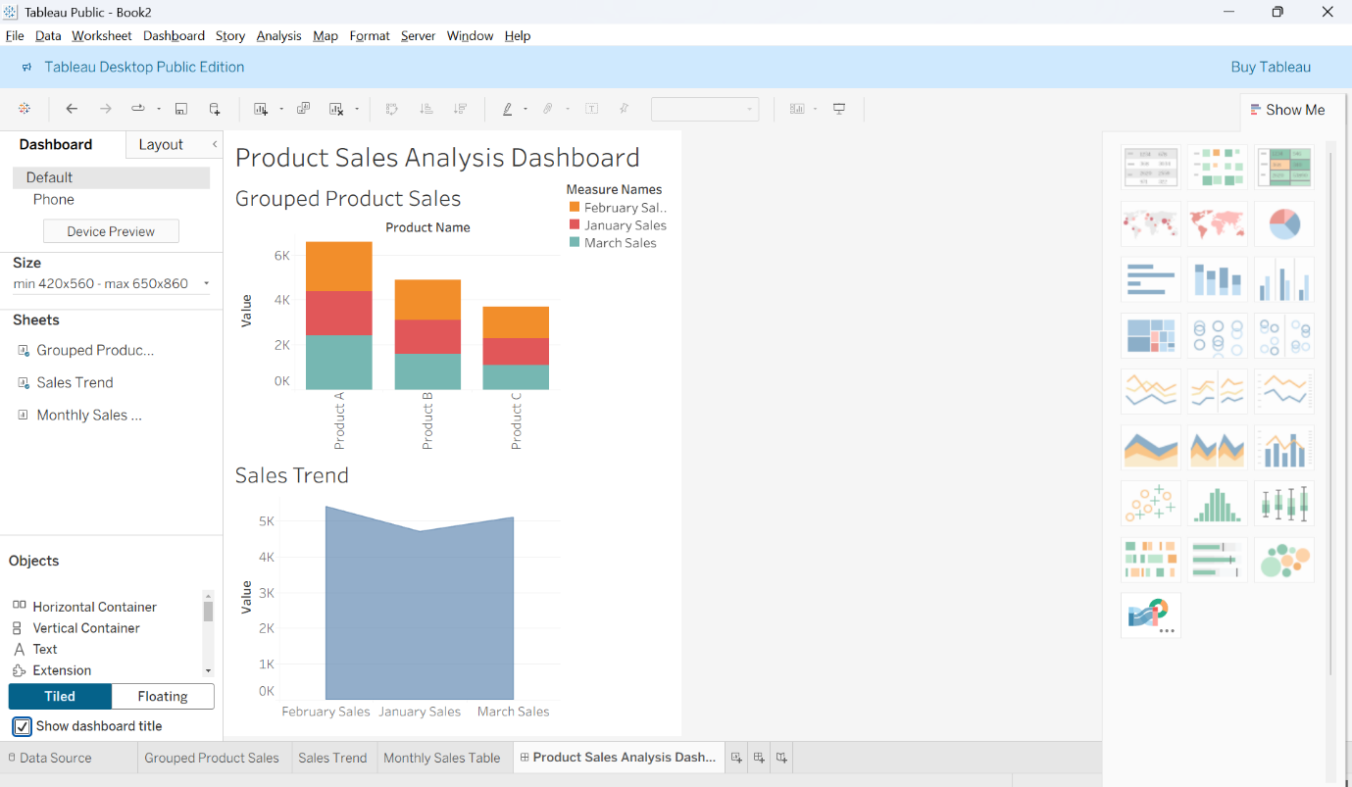
Output 4: Product Sales Analysis Tableau Dashboard

Observation
The dashboard displays product sales using a grouped bar chart, stacked area chart, and table, allowing users to compare the monthly sales of each product and analyze the overall sales trend. Interactive filters provide convenient exploration of the product sales data.

Set 6 Procedure
- Create a monthly product sales dataset containing Product ID, Product Name, January Sales, February Sales, and March Sales.
- Use R to create a grouped bar chart showing the sales of each product for the first quarter.
- Create a stacked area chart to represent the overall sales trend for all products over the three months.
- Create a table to display the monthly sales data for each product.
- Import the monthly product sales dataset into Tableau.
- Create a grouped bar chart, stacked area chart, and table in Tableau.
- Apply filters and dashboard actions for interactive exploration.
- Combine all three visualizations into a dashboard and save it.
Set 6 Result
Product sales data was successfully visualized using an R grouped bar chart, stacked area chart, and monthly sales table. A Tableau dashboard was also created to display and compare the monthly sales of each product interactively.

